
DST151 Depth Transducer
General
The DST151 is a low cost, nylon, transom mount transducer for use on sailboats and powerboats.

Specifications:
Frequency | 200 kHz
Dimensions | (see figure)
Cable length | 30’
Cable connector | RCA Phono Plug

Accessories
EX345D | 15’ depth extension cable

Note: Only one extension cable may be used for a total cable length of 45’.
It is not recommended to cut and splice transducer cable because performance may be affected.

Please refer to the Standard Horizon Transducer Installation Guide for detailed installation information.

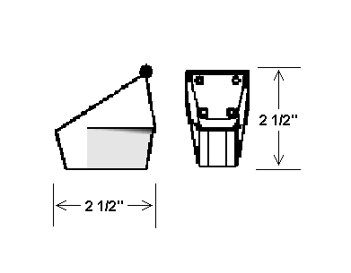
Figure 1. DST151 Depth Transducer

